Lead vehicle and slow with stationary object

# **Actors**

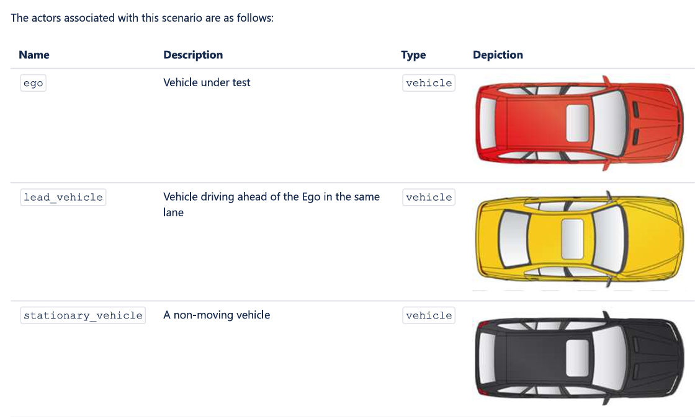

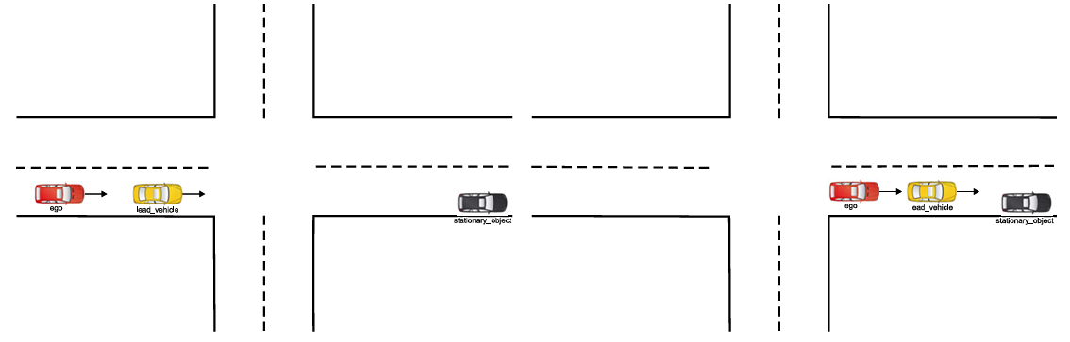

**Parameters**

